Milestone 4 report.
Project Food-Reservation
Name: Juan Montalvo
Shortcomings and issues of Project
- Perform validation of input fields in forms
- User account password security
- Responsive design for the application's tables and forms
- Loading images simultaneously when selecting a record (plate) in the form
Target features.
- Create new records in the database through the application (dishes, reservations, users).
- Edit records in the database through the application (dishes, reservations, users).
- Delete records in the database through the application (dishes, reservations, users).
- Create dynamic pages in the application, each page must be dynamic, according to the type of user who enters the application, the user will be able to see only certain information and functionalities.

Screenshots of the website:
Here the user will enter the application with their username and password:
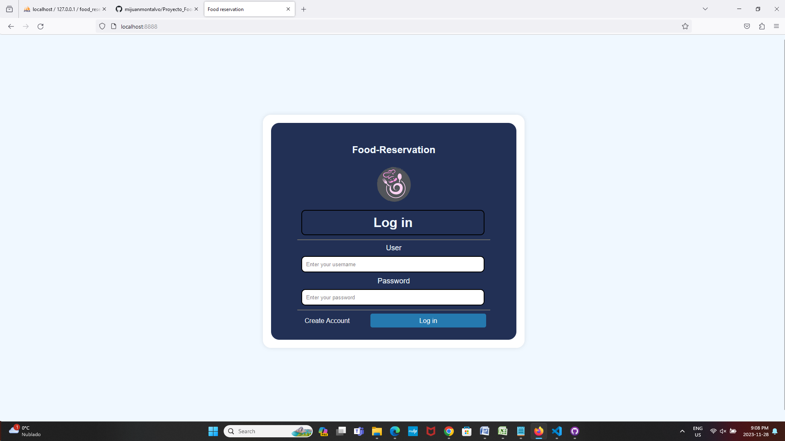
If the user does not have an account, they can create a new account, their account can be guest type or kitchen type:
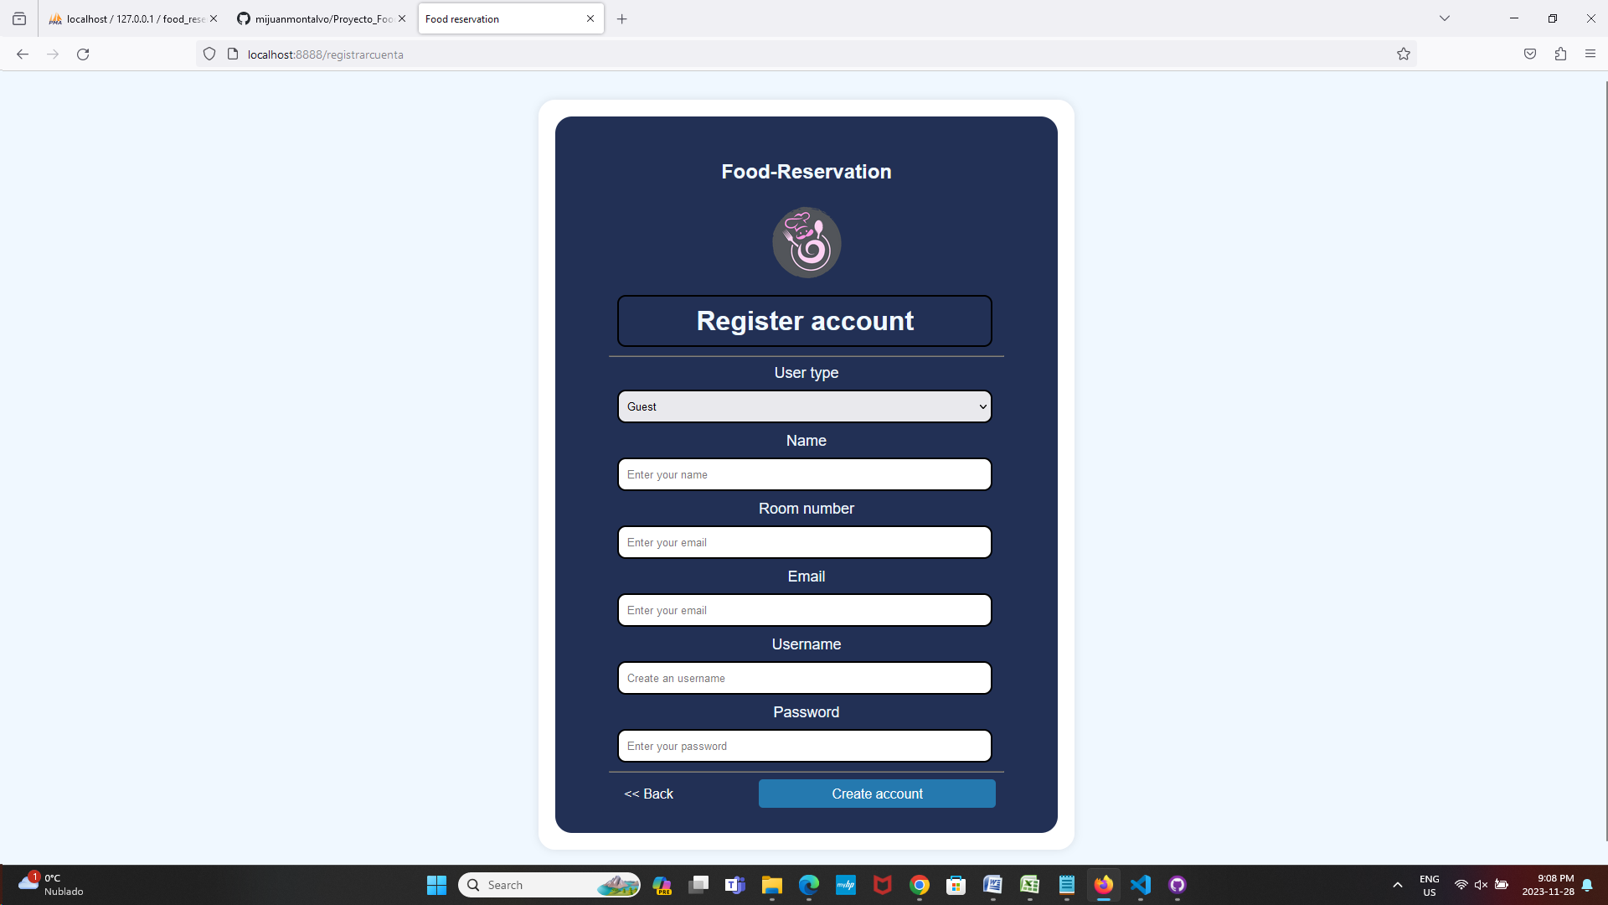

Application screens for guest users:
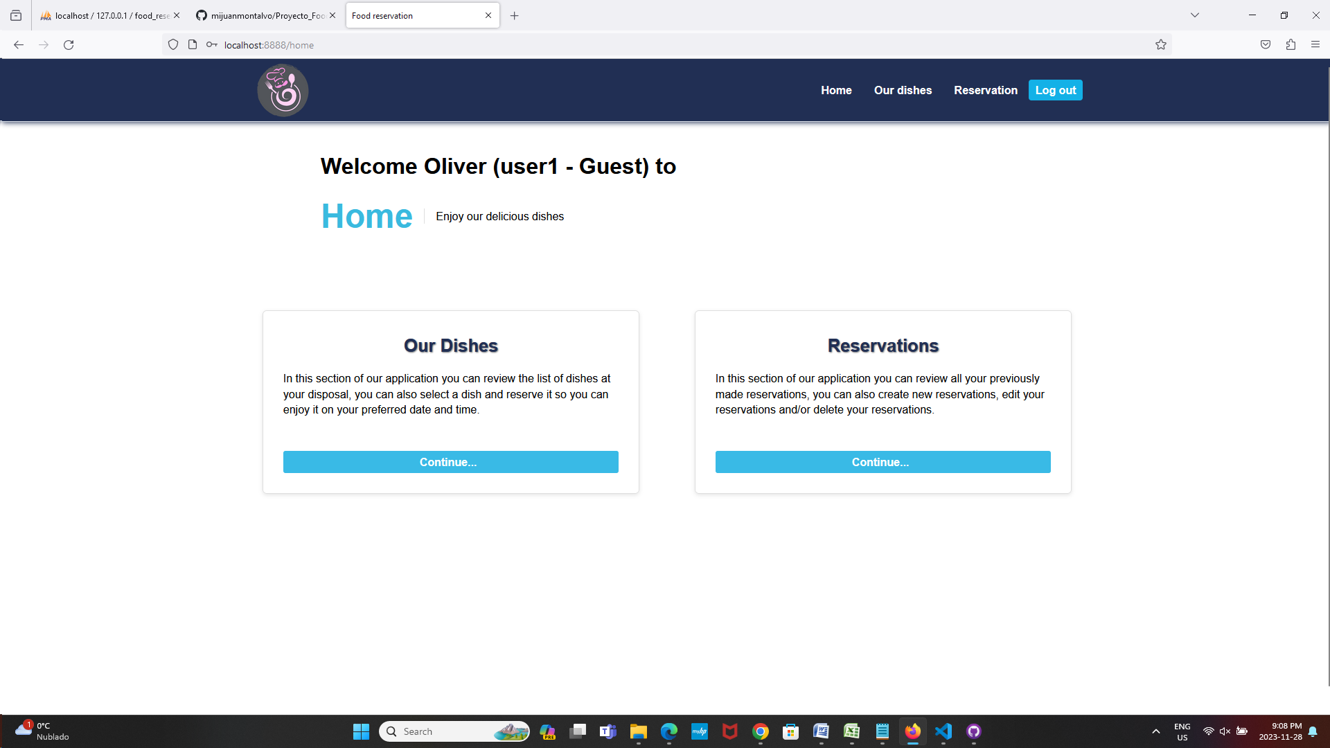
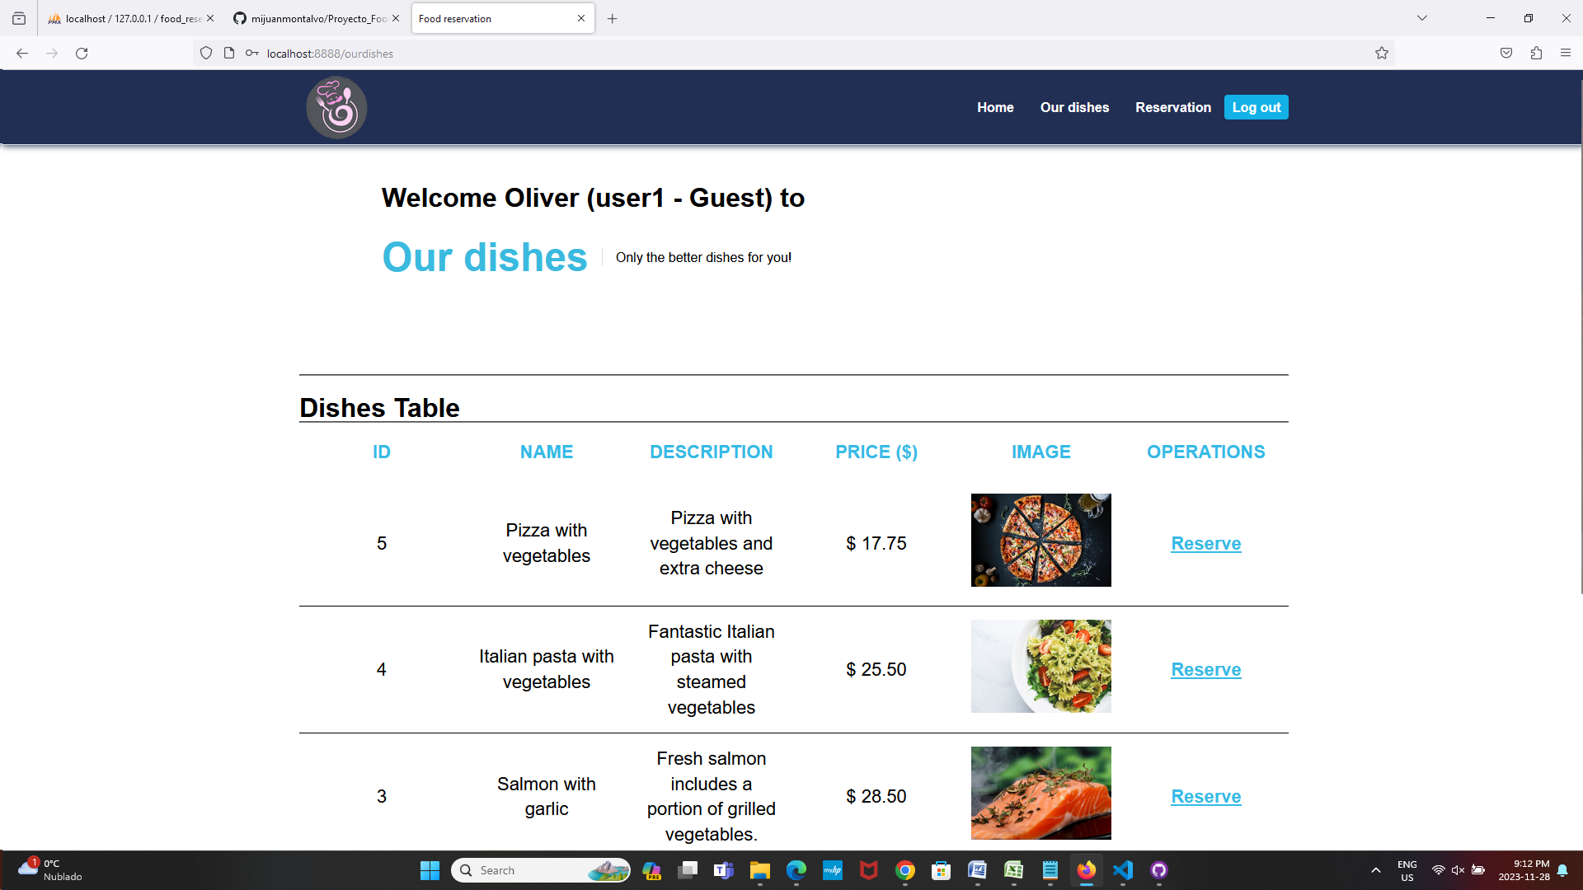

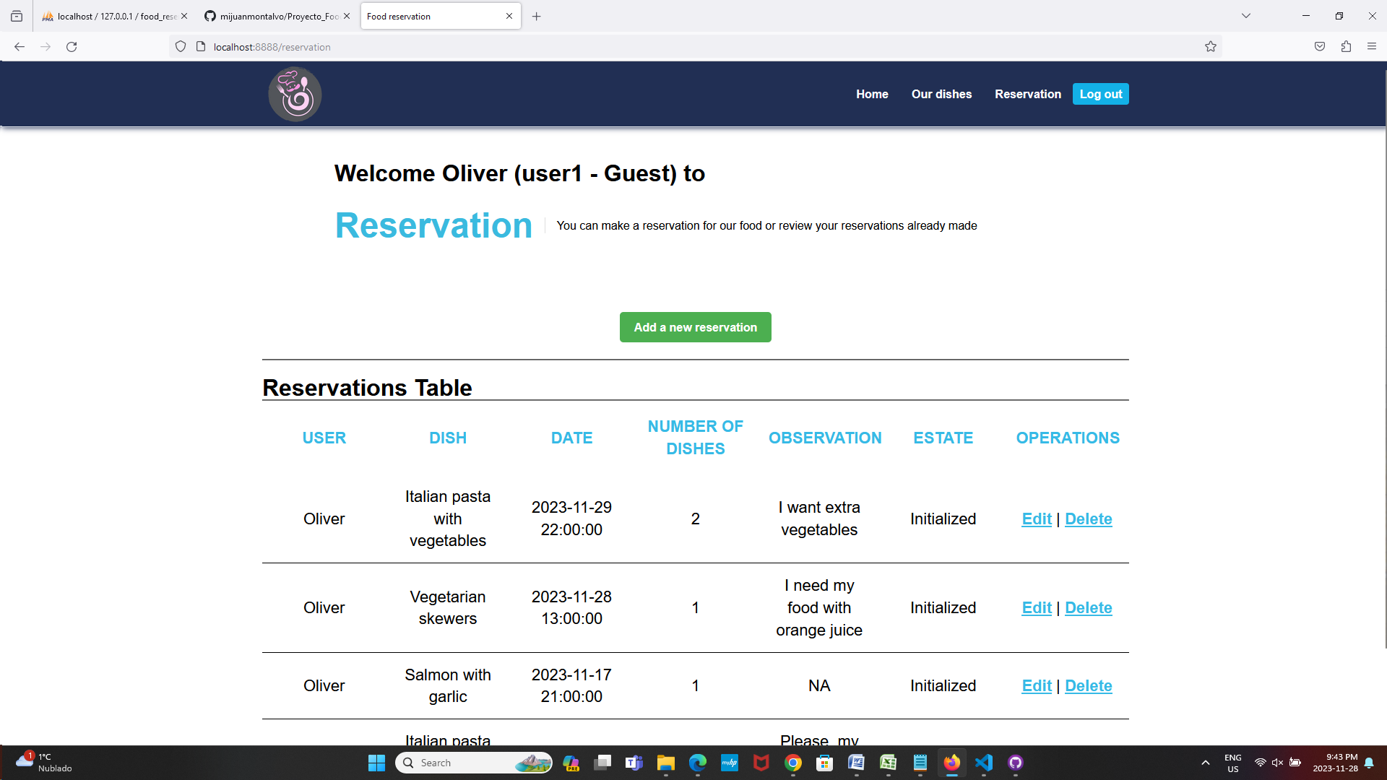

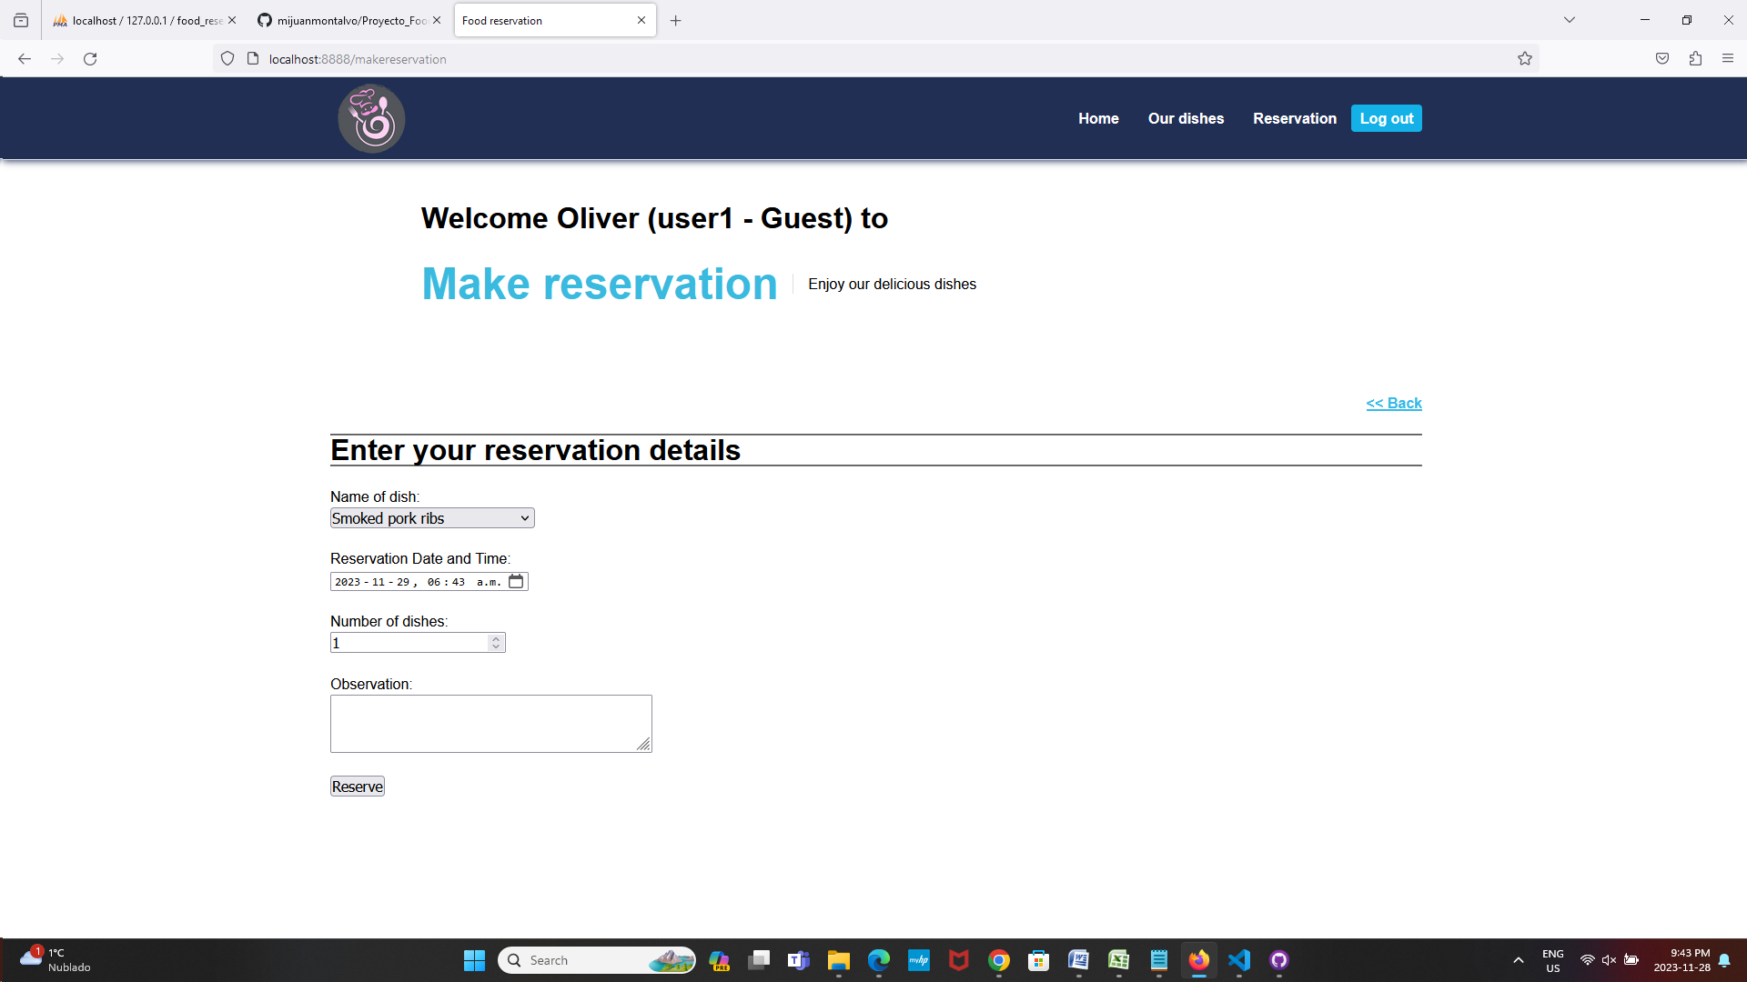
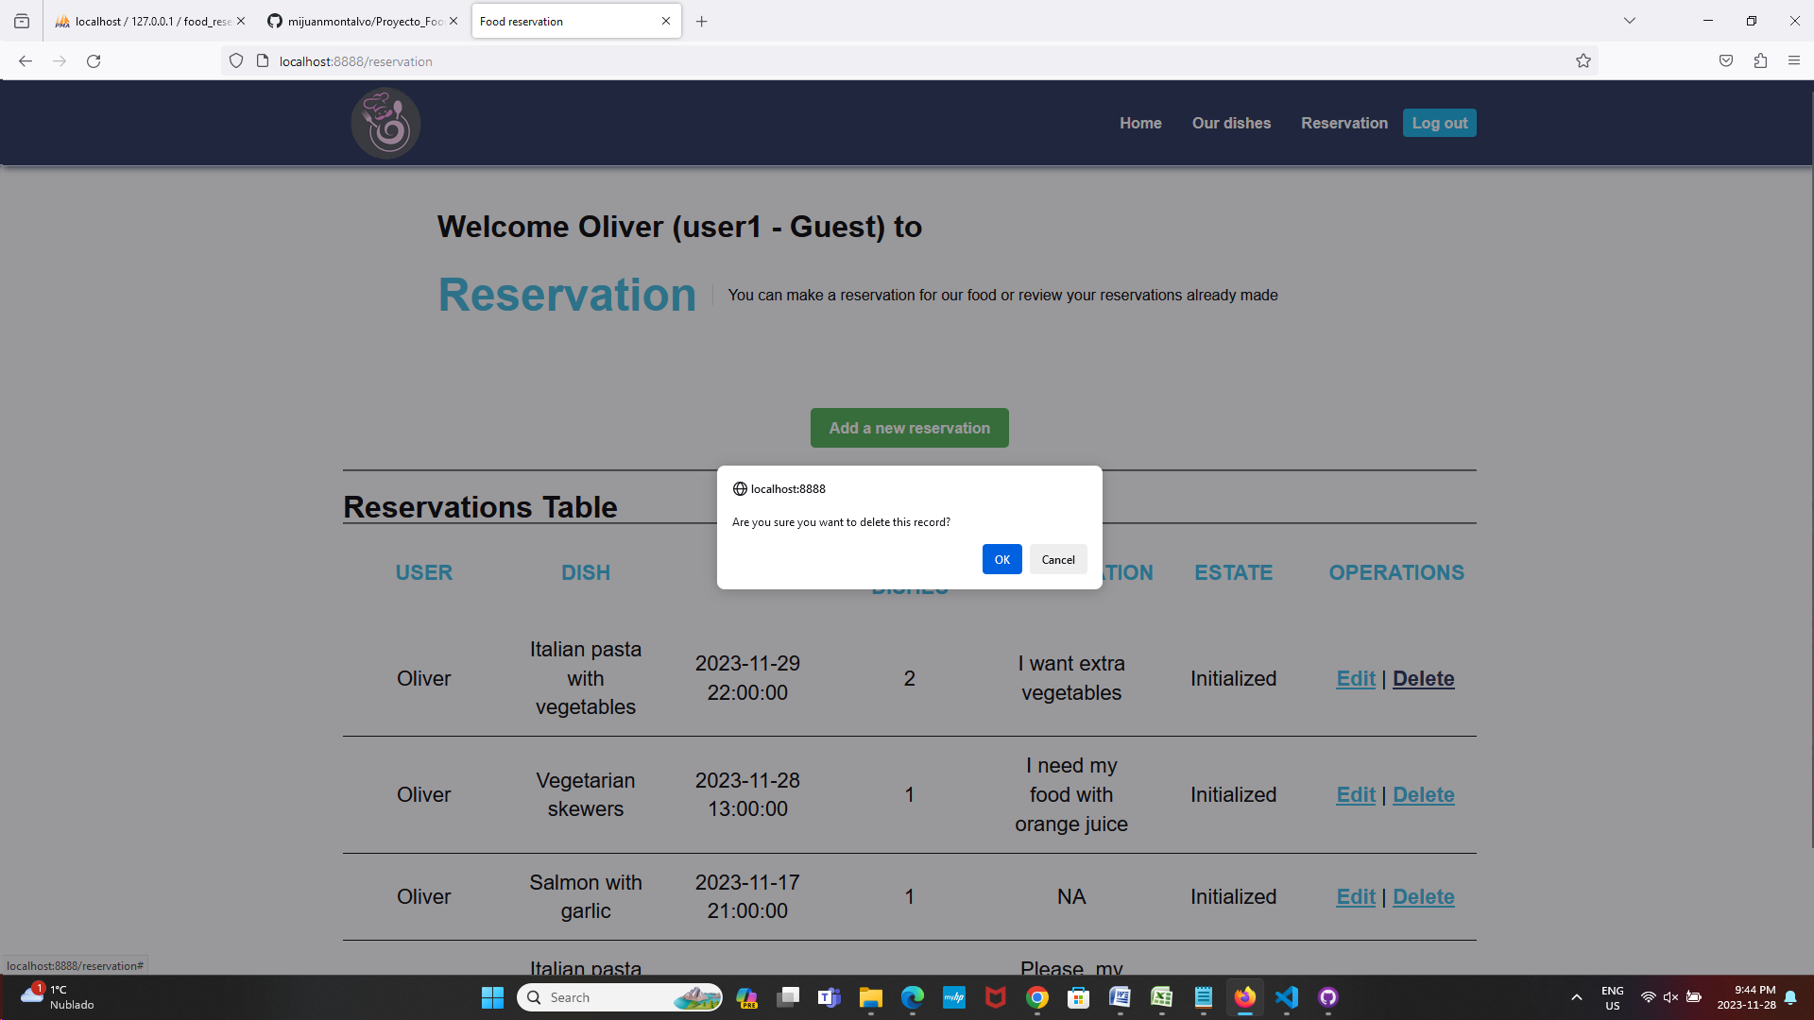

Application screens for kitchen type users:
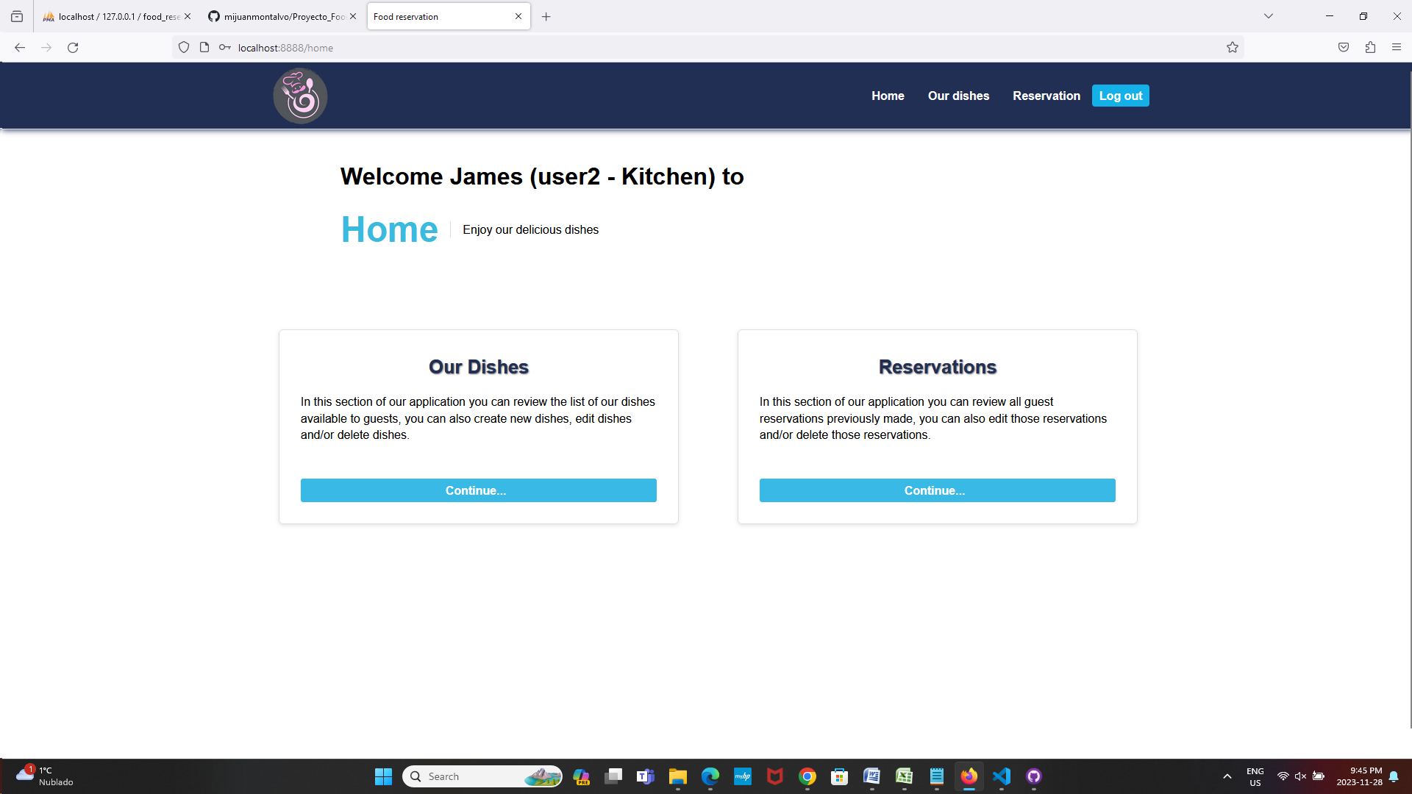

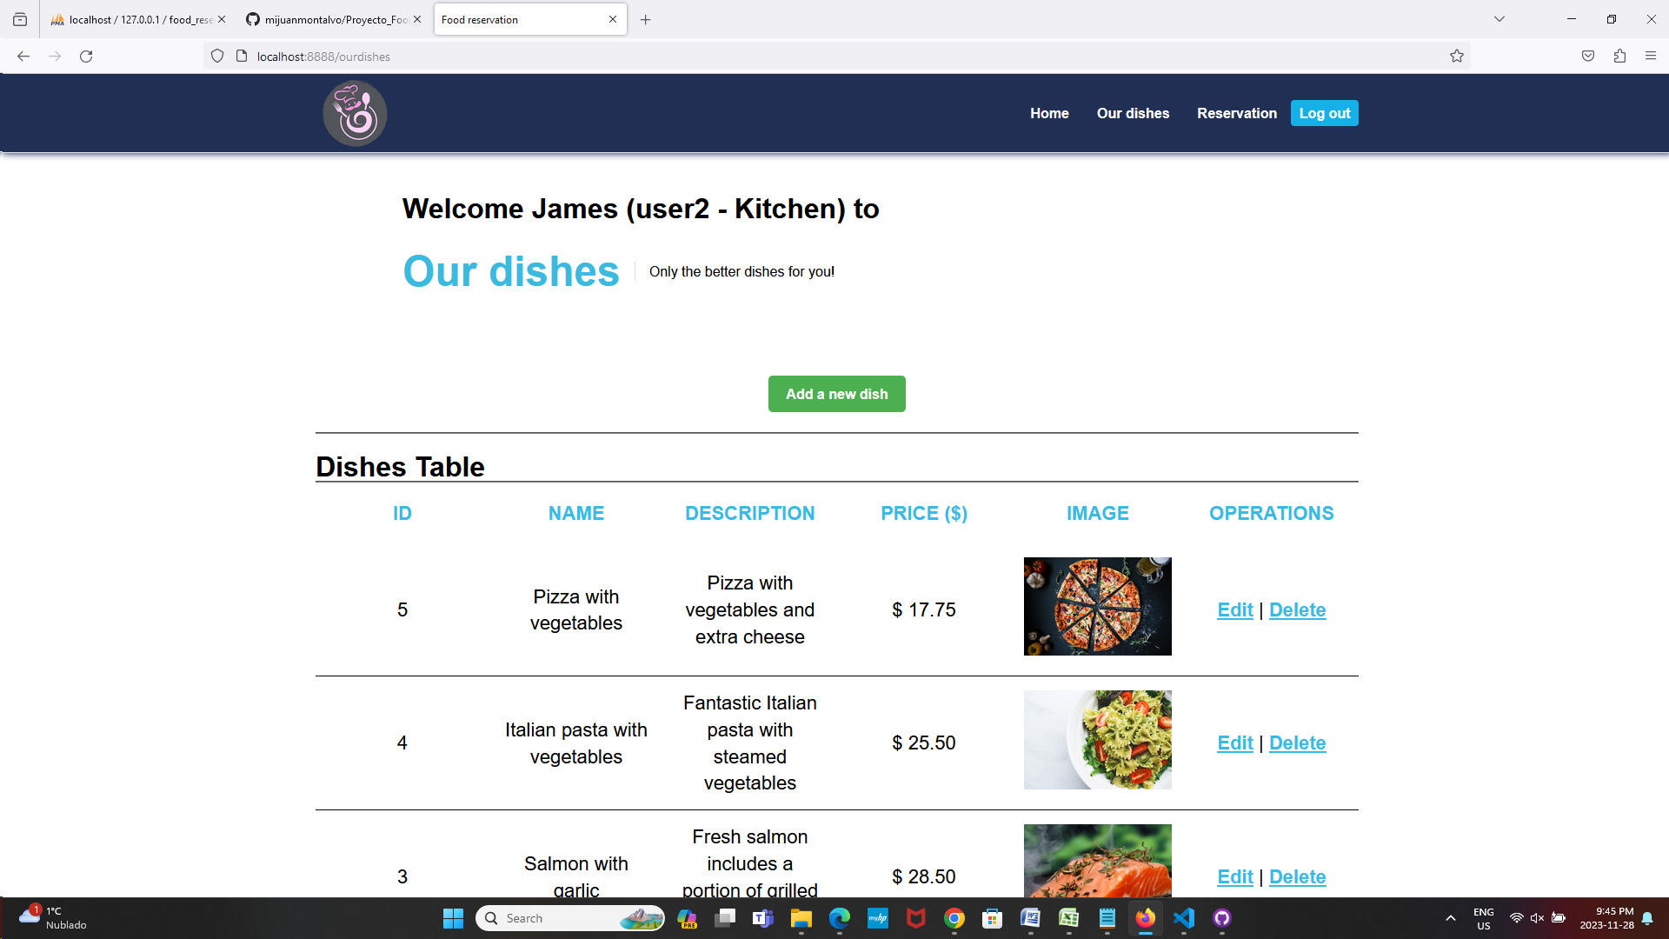
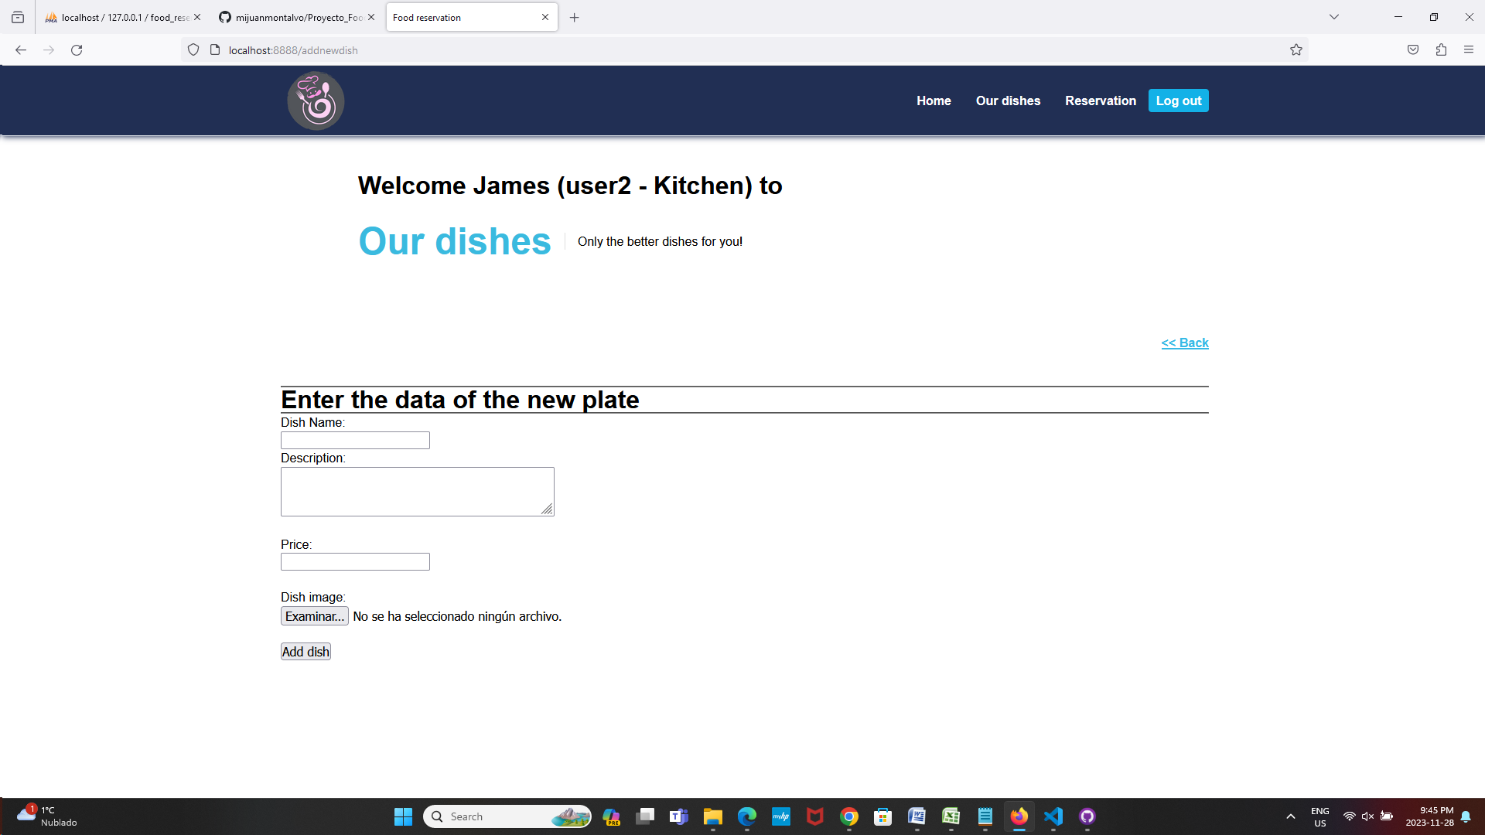
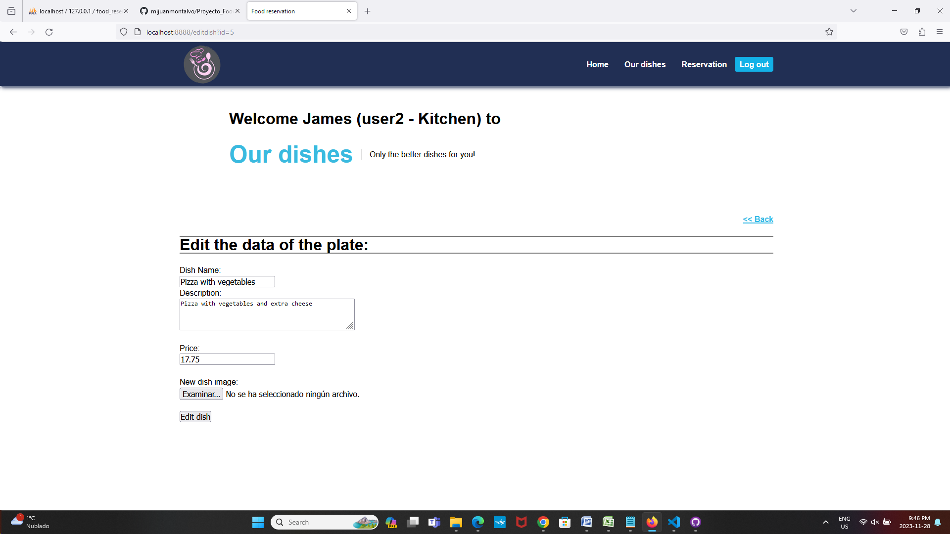
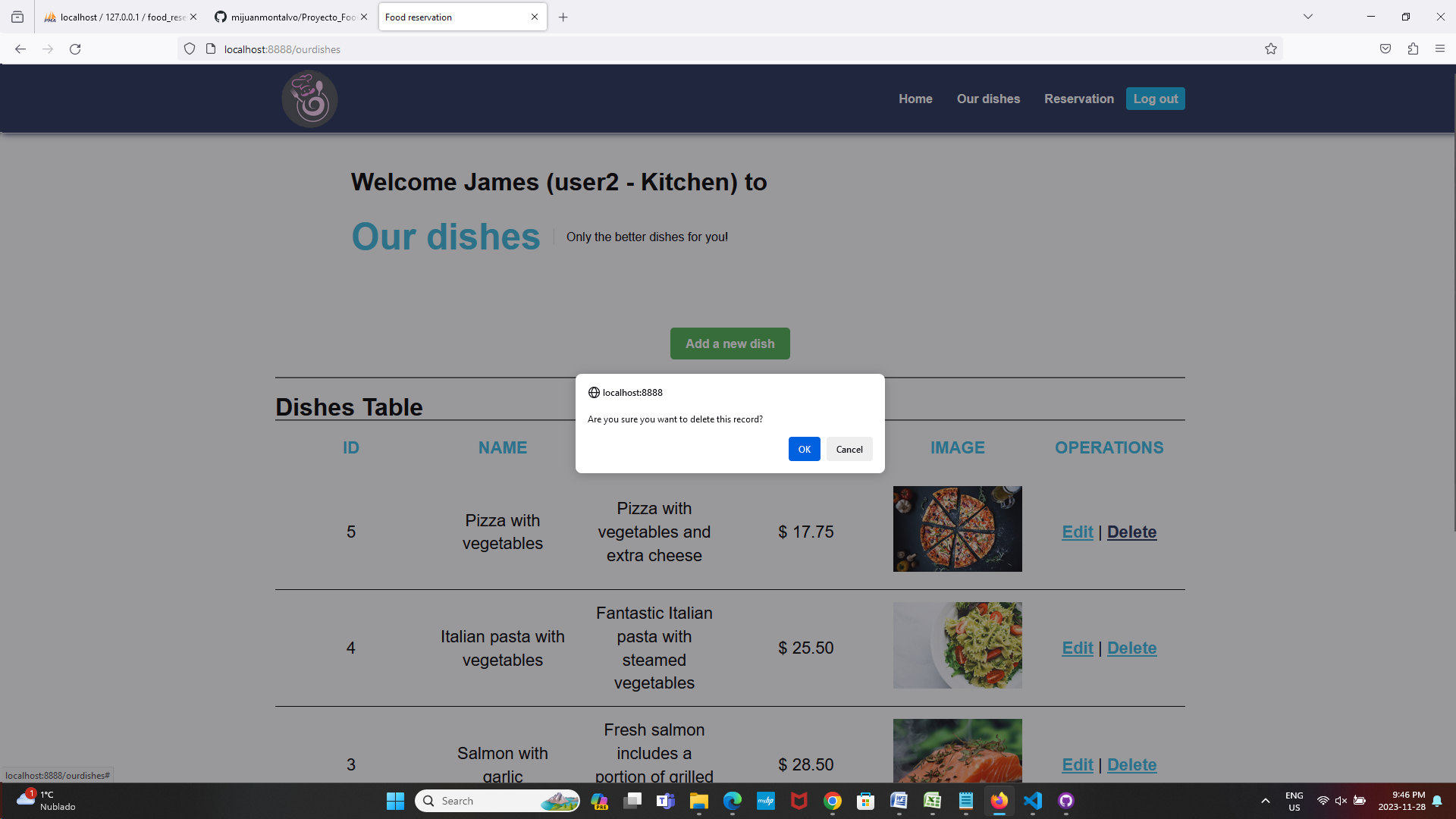

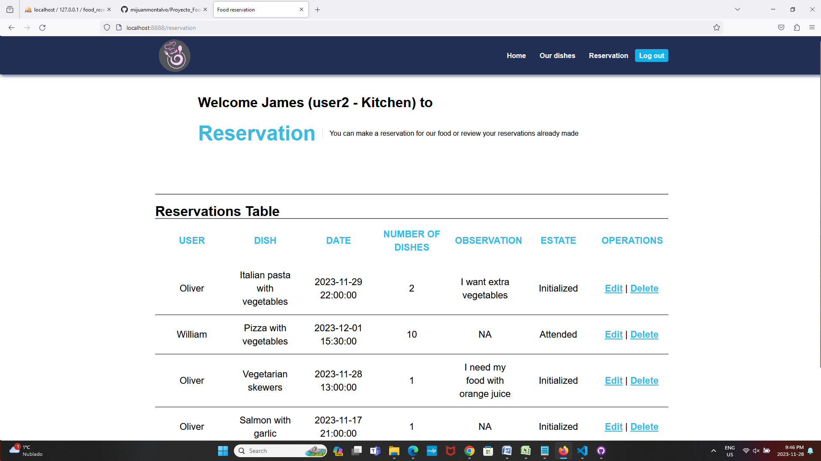
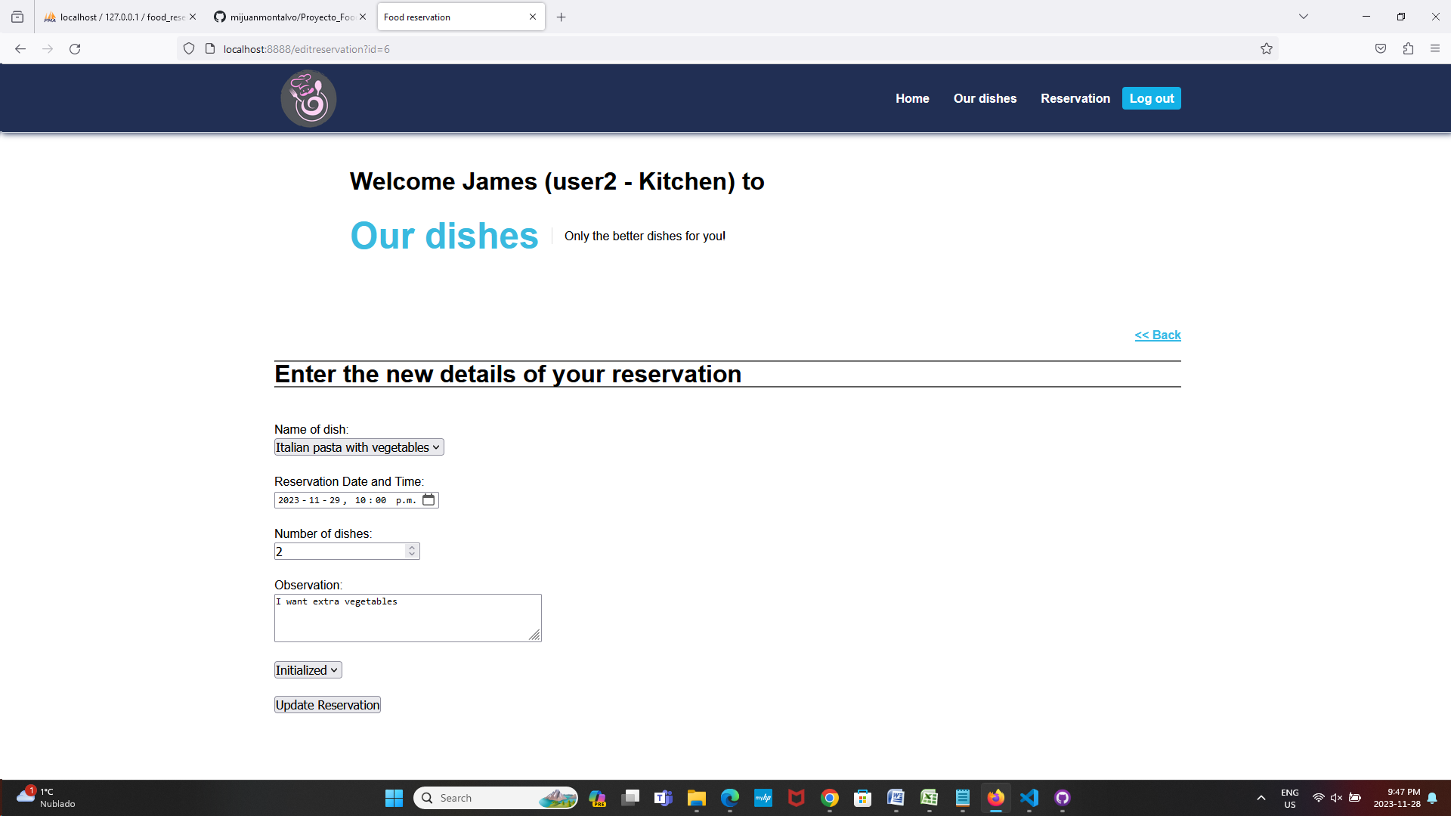
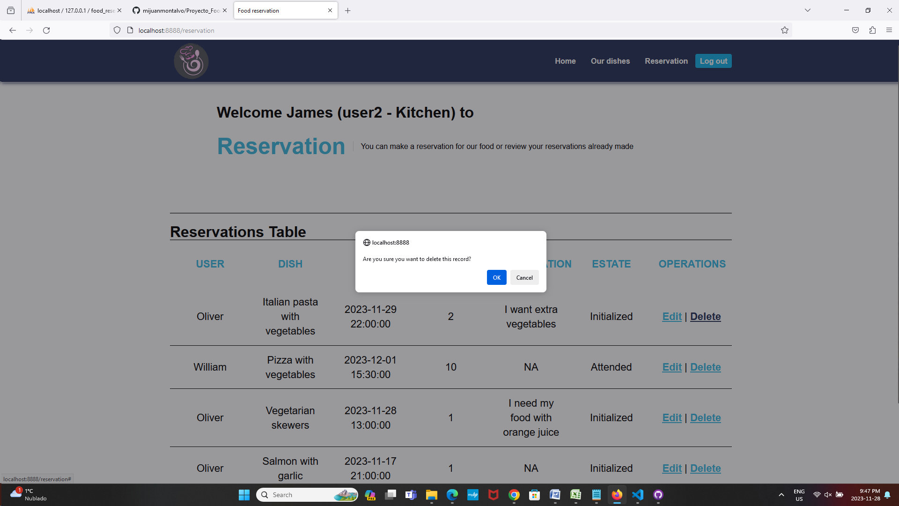

Description of project
My project is an application for food reservation (dishes from the kitchen of a hotel or residence), in this application there are two different types of users (Guest and kitchen). The guest user can review the dishes in the kitchen and can make reservations, and can also edit and delete the reservations made. The kitchen user will be able to review the list of existing dishes, create, edit and delete existing dishes, and will also be able to review all reservations made by guest users. Users can enter the application with a username and password, if they do not have a user account they will be able to create an account.

In this project I have learned to:
- Connect a PHP website with a MySQL database,
- Perform SQL statements and generate tables for PHP
- Make variable connections between several PHP pages through the GET and POST methods.
- Create a project structured through folders (controllers, view, etc.)
- Route the different pages of the project through a router.php file

URLs
GITHUB:
- https://github.com/mijuanmontalvo/Proyecto_Food_Reservation.git
AWS server: (dos carpetas de proyecto 3 y 4 hito )
- http://jmontalvomolina.imgd.ca/dgl123.jmontalvomolina.imgd.ca/1c/
- http://jmontalvomolina.imgd.ca/dgl123.jmontalvomolina.imgd.ca/1d/

